Klaipėda University
Faculty of Marine Technology and Natural Sciences Department of Informatics and Statistics
INTEGRATED QUERY LANGUAGE (LINQ) - (C#)

Laboratory work of the subject „Programming .NET“
Author: |  | X group, Firstname Lastname
Lecturer: |  | Robertas Jurkus
Klaipėda, 2024
- Write LINQ queries according to the following descriptions (Parts I and II).

Preliminary ProductPriceHistory JSON structure:  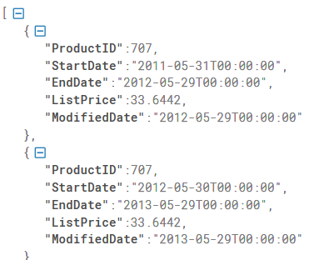 | Preliminary Product JSON structure:  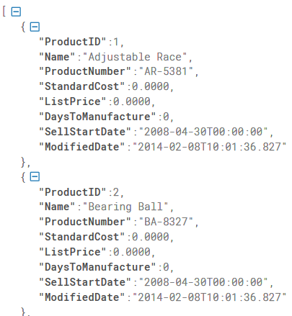

JSON data used for tasks

The JSON files are provided with the task description (ProductsPriceHistory.json, Products.json). Create classes (ProductPriceHistory, Product) based on the structure provided. You need to perform data import (deserialization) and list creation (list). In the examples, one line denotes one class object (instance). Note that some attributes may not have assigned values (NULL).

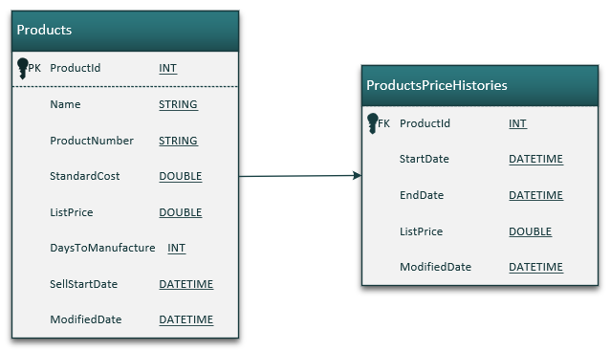

PART I
- Query (SELECT operator)
Use LINQ to create a new list with data (ProductPriceHistory) based on the task and the result provided.Each query must be written in two ways (Query syntax and Method (lamda) syntax):
- A query that returns all the data of an object, for example:
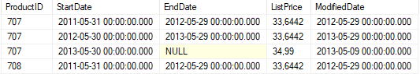
Implementation example: var TaskA = List.Select(c => c). ToList();

- A query that returns specific columns, for example:
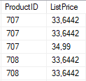

- Query (WHERE operator)
Using LINQ, follow the steps below to create the data lists, each query must be written in two ways (Query syntax and Method (lamda) syntax):
- A query that retrieves all the data (ProductPriceHistory) for a product with ID 739, for example:
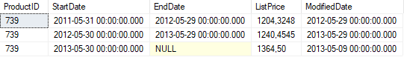
- A query that retrieves the active prices (for the columns provided) when EndDate is not NULL, for example:
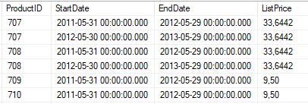

- Query (ORDER operator)
Use LINQ to create a new list with data (Product) according to the task and the result, create data lists, each query must be written in two ways (Query syntax and Method (lamda) syntax):
- Query, with specific attributes and sorting from A - Z by Name, for example:
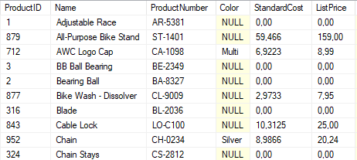

- Query with attributes and sorting from Z to A according to StandardCost, and change the Name column name to ProductName, for example:
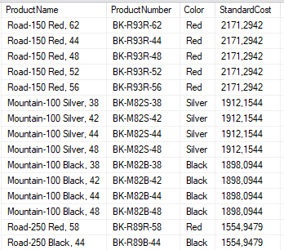

II DALIS
- Query (GROUPING operator)
Use LINQ to create a new list with data according to the task and the result, build the data lists, each query must be written in one of the chosen syntax (Query syntax or Method (lamda) syntax):
- A query that returns (ProductPriceHistory) each product and the highest price in the history of that product and how many price changes have been made, for example:
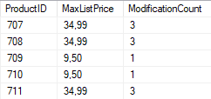
- Query that returns (Product) records grouped by Color and SizeUnitMeasureCode and calculates ListPrice sum, average, minimum, maximum, combines Color and SizeUnitMeasureCode into a single column, filtering by ProductName, records that start with "BK-" characters, for example:
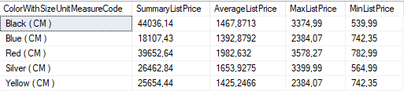

- Query (JOIN operator)
Use LINQ to create a new list with data according to the task and the result, build the data lists, each query must be written in one of the chosen syntax (Query syntax or Method (lamda) syntax):
- Example of a query that combines the ProductListPriceHistory and Product (via ProductID) tables/lists and selects the required data attributes from both:
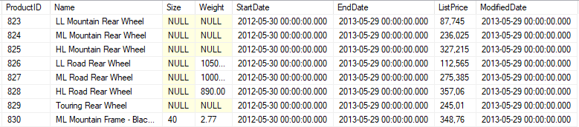

- A query that lists the first and last published price history for each Product record (ProductID, Name) and the first and last published price history for that product (StartDate - min and max, multiple joins may be required). The list should only consist of records where the FirstPrice and LastPrice are different, for example - 77 records in total:
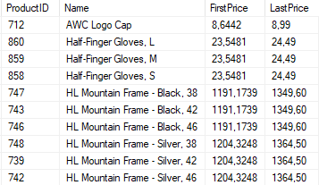

- Query
Use LINQ to create a new list with data according to the task and the result, build the data lists, each query must be written in one of the chosen syntax (Query syntax or Method (lamda) syntax):
Additionally, perform a serialisation of this list, saving the data to JSON.
- Query that retrieves the StartDate prices and items valid in 2012 and 2013. The data is sorted by Name in ascending order. The historical data is joined to the Product list and the average price history for each product is calculated. In addition, the first 3 records have to be discarded and only the next 5 records have to be taken. Example of the resulting list:
